Structure of database:
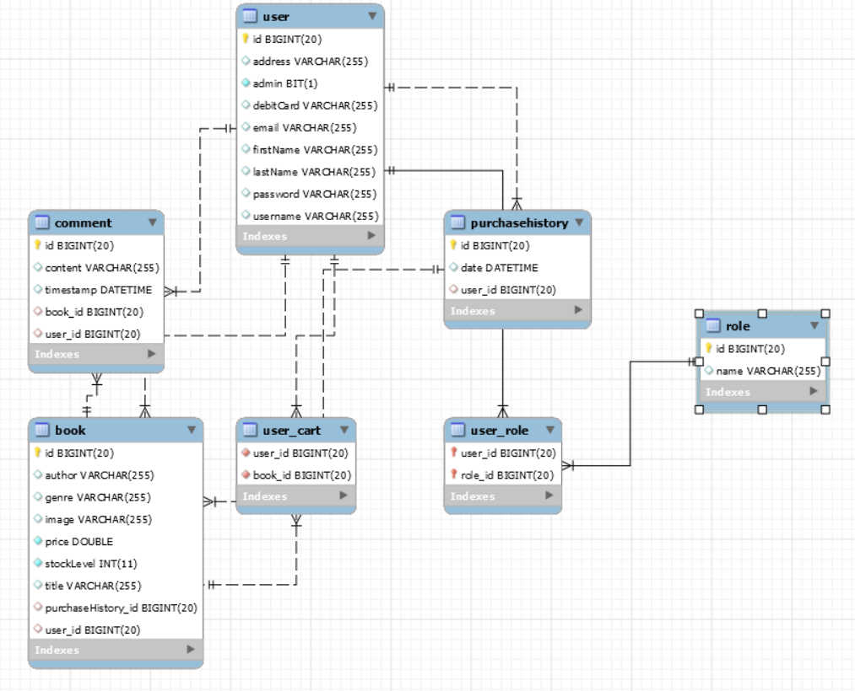
There is one user object but two users, a customer and an admin. This is done using the role feature of Spring Security.
A user can create an account or login. Once logged in in, the role of the user determines its actions. An admin can create, edit, update a book. A customer can add a book to cart, comment on books, buy books, view purchase history and edit account details.
Use of Patterns
Singleton pattern – This is used in the Service classes as these classes remain stateless. Example: (this is also used for the other objects)
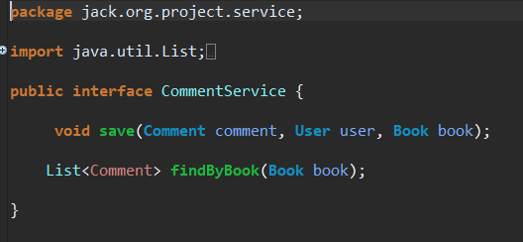
Model-view-controller pattern- This pattern is used to separate an applications concerns.
- Model – represents objects and POJOs.
- View – represents displaying of data the model contains
- Controller – represents the control of data flow between model and view.
Example:
MODEL
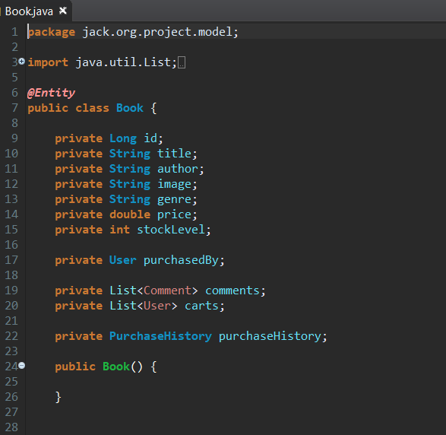

VIEW
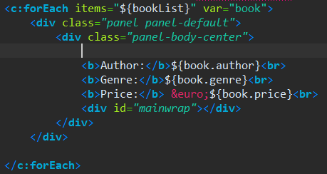

CONTROLLER
